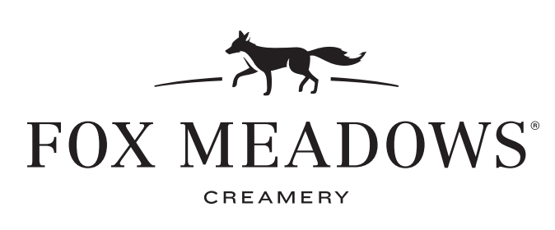

***Size***

***Small – 2 scoops – 4.40***

***Medium – 3 scoops – 5.40***

***Large – 4 scoops – 6.40***

***Sampler – 4 mini scoops – 5.60***

***Fox Paw – 1 Fun Scoop – 3.20***

**Visit Us!**

***Farmstead Location (Ephrata)***

2475 W Main St,

Ephrata, PA 17522

***Leola Location***

193 E Main St,

Leola, PA 17540

***Custom Float***

Glass bottle soda with any flavor of ice cream

• Mexican Coca Cola, Crème, Red Birch Beer, Orange, Root Beer•

6.00

***Affogato***

Any flavor of ice cream drowned in freshly brewed espresso

Topped with whipped cream and Biscoff Cookie

6.50

***Roasted Milkshake***

Any flavor of ice cream mixed with freshly brewed espresso

16oz Medium – 6.00 • 20 oz Large – 7.00

***Custom Milkshake***

Any flavor of ice cream mixed with farm fresh milk

16oz Medium – 5.70 • 20 oz Large – 6.70

***Ice Cream***

Any Favor

Extra Scoop on the side +1.50

***Classics***

Coffee

Cookies n’ Cream

Madagascan Vanilla

Mint Chocolate Chip

Wilbur Chocolate

***Chocolates***

Chocolate Peanut Butter Bliss

Mocha Brownie

***Fruits***

Chocolate Covered Strawberry

Vine Ripened Black Raspberry

***Dairy Free Sorbets***

Passion Fruit Guava Sorbet

Key Lime Pie Sorbet

***Nuts***

Brown Butter Almond Brickle

Nutella

Peanut Butter Cup

***Sweets***

Birthday Cake

Cookie Doughlicious

Honeyed Lavender

Salted Caramel Pretzel

***Featured Flavors***

Mango + Sticky Rice

Simply Strawberry

Grasshopper

Tandy Cake

Brookie Dough

Blueberry Country Cobbler

Orange Creamsicle

***Baked Fox***

Hot pressed outer shell with cold ice cream inside! – 6.70

***Outer* Shell**

Chocolate Chip Cookie

Chewy Brownie

Strawberry Shortcake

Chocolate Cake Roll

***Serving***

***Cake Cone or Dish***

***Homemade Waffle Cone +1.35***

***Homemade Waffle Bowl +1.35***

***Add a Shuey’s Pretzel +1.39***

**Farm Fresh Favors**

**Ice Cream + Signature Treats**